# **Mini project Report**

**(KCS-554)**

**HARSHIT GOEL,MAYANK BORA**

**CSE 3B**

**1816110081,1816110110**

**Even Semester**



**Department of Information Technology**

**KRISHNA ENGINEERING COLLEGE**

95, Loni Road, Mohan Nagar, Ghaziabad (Uttar Pradesh), Pin-201007

ABSTRACT

It is a website application that takes experience , test score and interview score as input and gives us the predicted salary of a person.

For it we have taken dataset from kaggle and used machine learning algorithms for making model and flask and heroku for deploying the model .

INTRODUCTION

The project was about to predict the salary of a person on the basis of experience , test score and interview score. It is a web app and uses machine learning algorithms and techniques to create the model. We also used heroku and flask for deploying the model to make it a web app . Here we have use python language and it’s various libraries in this project.

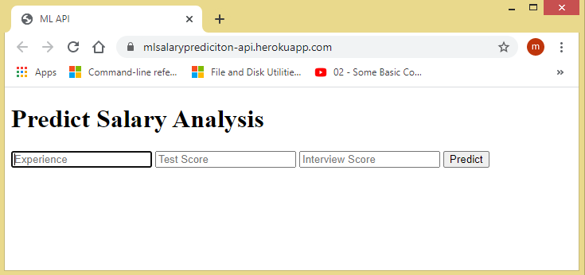It is the first interface of the website

BACKGROUND STUDY

Our project works on python language and uses it’s various libraries like numpy , pandas , matplotlib , sklearn. We used machine learning techniques like linear regression to make our model. Then we use flask and heroku to deploy the model and make it as a website application.

It is github repository link of project:-https://github.com/goelharshit562/Heroku_deploy.git

WORKING OF PROJECT

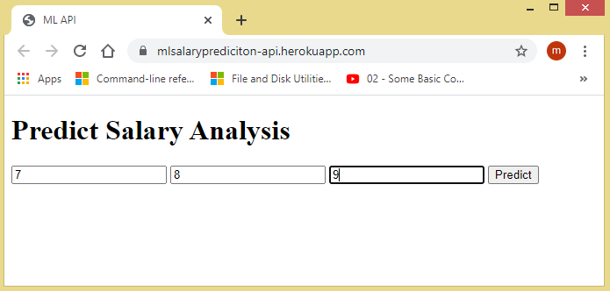We have taken 7, 8 and 9 as Experience , test score and interview score respectively.

After computation of the program it will show the predicted salary of a person according to your input.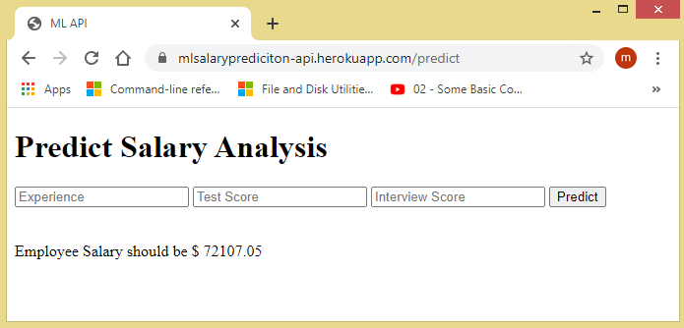

It is the website application link of project:-https://mlsalaryprediciton-api.herokuapp.com/

FUTURE SCOPE AND REFERENCE

Machine learning can be used to predict various things like weather forecasting, job scope and salary trends, computer vision , etc.

We have taken the dataset from kaggle website.

1. Andreas Mullar, “Introduction to Machine Learning using Python: A guide for data Scientist,” in O’R eilly Publisher, India.

2. S. Marsland, Machine learning: an algorithmic perspective. CRC press, 2015.

3. A. L. Buczak and E. Guven, “A survey of data mining and machine learning methods for cyber security intrusion detection,” IEEE Communications Surveys & Tutorials.